**BSCS FINAL PROJECT PROPOSAL**

Real-Time OS for STM based Microcontrollers

*Term of Registration: Fall 2017*



Presented by:

|  |  |
| --- | --- |
| **Registration No:** | **Name:** |

*L1S14BSCS0067 Sunmbal Sofia*

*L1F13BSCS2392 Saad Shahid*

*L1F13BSCS2015 Muzahir Hussain*

|  |
| --- |
| Faculty of Information Technology |

University of Central Punjab

**Project Title**

Real-time Operating System for STM based Micro-controllers.

**Project Advisor**

Prof. Adnan Ghafoor

**Particulars of the students:**

|  |  |  |  |  |
| --- | --- | --- | --- | --- |
| **S.No** | **Registration#**  eg.**L1F00BSCS0101** | **Name in Full**  Use Block Letters | **CGPA** | **Signatures** |
| 1 | L1S14BSCS0067 | SUNMBAL SOFIA | 3.32 |  |
| 2 | L1F13BSCS2392 | SAAD SHAHID | 2.41 |  |
| 3 | L1F13BSCS2015 | MUZAHIR HUSSAIN | 2.61 |  |

**Advisor’s Consent**

I Prof. Adnan Ghafoor am willing to guide these students in all phases of above-mentioned project as advisor. I have carefully seen the Title and description of the project and believe that it is of an appropriate difficulty level for the number of students named above.

|  |  |  |
| --- | --- | --- |
| **Note:**  Advisor can’t be changed without prior permission of the Manager Projects and the duration for completion of the Project is 2 regular semesters (approx.) from the date of Registration of Research Project. | Signatures and Date  |  | | --- | |  |   **Advisor** |

**EVALUATOR/REFEREE 1**

|  |  |  |  |  |  |
| --- | --- | --- | --- | --- | --- |
| I have carefully read the project proposal and feel that the proposed project is a useful one and of a sufficient difficulty level to justify 2 regular semesters workload for above mentioned students. I have made recommendations in the evaluation form to improve the scope and quality of the project. | | | | | |
|  | | | | Signatures and Date | |
|  |  |  |  |  |  |
|  | | | |  |

**EVALUATOR/REFEREE 2**

|  |  |  |  |  |  |
| --- | --- | --- | --- | --- | --- |
| I have carefully read the project proposal and feel that the proposed project is a useful one and of a sufficient difficulty level to justify 2 regular semesters workload for above mentioned students. I have made recommendations in the evaluation form to improve the scope and quality of the project. | | | | | |
|  | | | | Signatures and Date | |
|  |  |  |  |  |  |
|  | | | |  |
|  | | | |  |  |

**Abstract / Executive Summary**

The core objective of this project is to design and implement real time Operating system for STM32 based microcontrollers. It will incorporate multitasking along with other functionalities that will help the embedded system programmer to write codes with great comfort. The library would include functions to access various on-chip resources like Timer, USART, ADC, DAC, GPIOs quickly. This will make the usage of STM based microcontrollers as simple as Arduino is.

**Introduction and Background**

In STM based microcontrollers, user faces a hard time to write even simple piece of code. Secondly, in depth understanding of underlying device is required to program the device.

Multi-tasking is hard to achieve. Lot of programmer time is spent to implement the basic functionalities and device configurations than to the actual problem solving.

We are proposing a real time operating system that will facilitate the user to create multiple tasks simple by calling a single function. Tasks creation and deletion would become so simple. Semaphore would be implemented for task synchronizations.

Library would be provided to interact with all the hardware resources available in the chip with great ease.

The proposed OS would be easy to use and learn. It utilize the available resources efficiently.

**Statement of the Problem**

The project will address the problem of embedded programmers to save their time to focus more on the efficient algorithms instead of doing complex coding. STM board does not have its own OS so we are building some libraries, which will be included in the code, in order to avail the services of OS.

**Objective(s) / Aim(s) / Target(s)**

Provide library to access Timer, ADC, DAC, USART and GPIOs.

Provide multi-tasking

Provide semaphores for task synchronization.

**Completeness Criteria**

The project would be complete if,

* It creates and delete tasks.
* It executes tasks with multi-tasking.
* It provides task synchronization mechanism.
* It provides simple functions to access various controllers.

**Challenges**

* Understand the STM board in depth.
* Understand the working of all the on-chip resources including ADC, DAC, USART, Timers and GPIOs.
* Learn how to achieve multi-tasking using timer and interrupts.

**Knowledge Areas Required**

Knowledge of following areas is very important:

* Working of an Operating System.
* Working of an Embedded System.
* To operate IDE’s supporting STM32 to produce the required outcome.
* C programming.
* Assembly language.

**Learning Outcomes**

* A great deal of knowledge of embedded systems programming.
* STM32 micro-controllers.
* Operating System working.
* Experience of writing real time OS.
* Working of Processors.

**Nature of the End Product / Research Outcomes**

End product will be a library that must be included and it’s functions are to be used in order to acquire the services of this OS.

**Deliverables / Work Breakdown Structure**

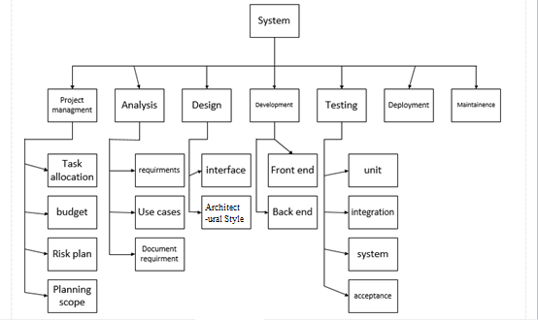

**Project Plan / Project Schedule / Project Timetable / Project Calendar**

|  |  |  |  |  |
| --- | --- | --- | --- | --- |
| **Number** | **Task** | **Start Date** | **End Date** | **Duration(Days)** |
| 1 | Project Idea | 6/16/2017 | 6/21/2017 | 3 |
| 2 | Project Proposal | 8/30/2017 | 8/30/2017 | 7 |
| 3 | **Requirement Gathering** | **10/26/2017** | **12/15/2017** | **50** |
| 4 | Functional Requirements | 10/26/2017 | 11/5/2017 | 10 |
| 5 | Non-Functional Requirements | 11/5/2017 | 11/13/2017 | 8 |
| 6 | External Interface Requirements | 11/13/2017 | 11/21/2017 | 8 |
| 7 | Dependencies | 11/21/2017 | 11/29/2017 | 8 |
| 8 | SRS Version l | 11/29/2017 | 12/11/2017 | 12 |
| 9 | **Analysis and Design l** | **12/20/2017** | **2/8/2018** | **50** |
| 10 | **Analysis and Design ll** | **3/4/2018** | **5/13/2018** | **70** |
| 11 | Analysis | 12/20/2017 | 1/19/2018 | 30 |
| 12 | Use Case Diagram | 1/19/2018 | 1/29/2018 | 10 |
| 13 | ER Diagram | 1/29/2018 | 2/8/2018 | 10 |
| 14 | Class Diagram | 2/8/2018 | 2/8/2018 | 0 |
| 15 | Design | 2/8/2018 | 2/18/2018 | 10 |
| 16 | High-Level Design | 2/18/2018 | 2/28/2018 | 10 |
| 17 | Low-Level Design | 2/28/2018 | 3/10/2018 | 10 |
| 18 | Component Diagram | 3/10/2018 | 3/25/2018 | 15 |
| 19 | Deployment Diagram | 3/25/2018 | 4/9/2018 | 15 |
| 20 | **System Architecture** | **4/9/2018** | **5/14/2018** | **35** |
| 21 | Diagrams | 4/9/2018 | 4/14/2018 | 5 |
| 22 | Screen Shots | 4/14/2018 | 5/4/2018 | 20 |
| 23 | SRS Version ll | 5/4/2018 | 5/19/2018 | 15 |
| 24 | **Final Phase** | **5/19/2018** | **8/17/2018** | **90** |
| 25 | Test Cases | 5/19/2018 | 6/8/2018 | 20 |
| 26 | Implementation | 6/8/2018 | 7/8/2018 | 30 |
| 27 | Testing | 7/8/2018 | 7/28/2018 | 20 |
| 28 | SRS Version lll | 7/28/2018 | 8/17/2018 | 20 |

**Gantt chart**

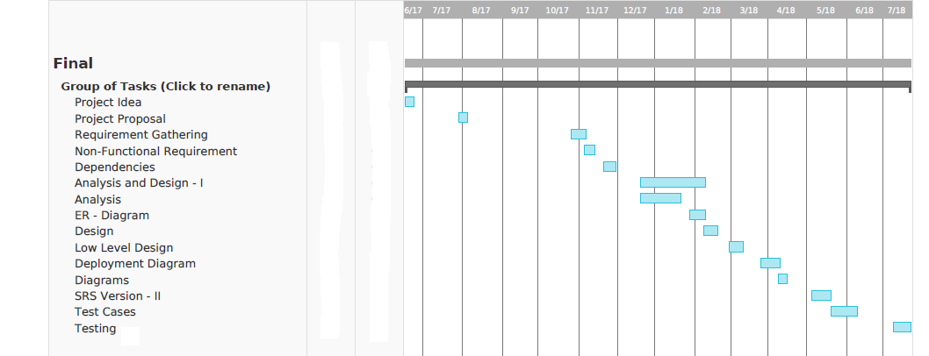

**Resources Required**

Following resources are required:

* STM board.
* Project Lab PC.
* KEIL/CoIDE software.
* Other Hardware.

**References/Bibliography**